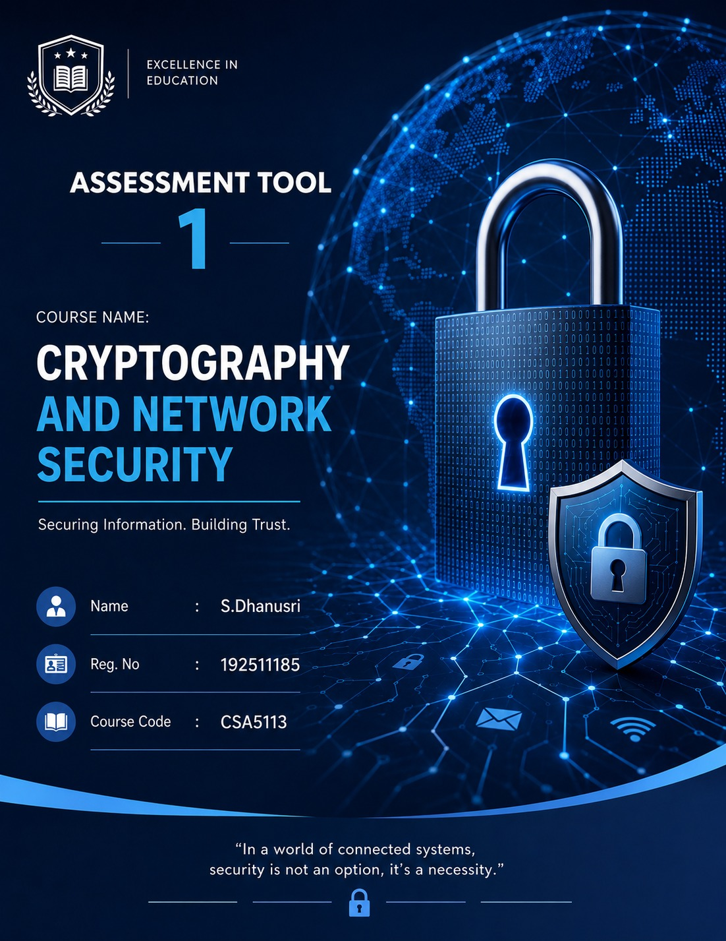
- Implement and compare MD5 and Secure Hash Algorithm (SHA-256) in Python by hashing multiple input messages. Analyze their collision resistance and
performance differences.

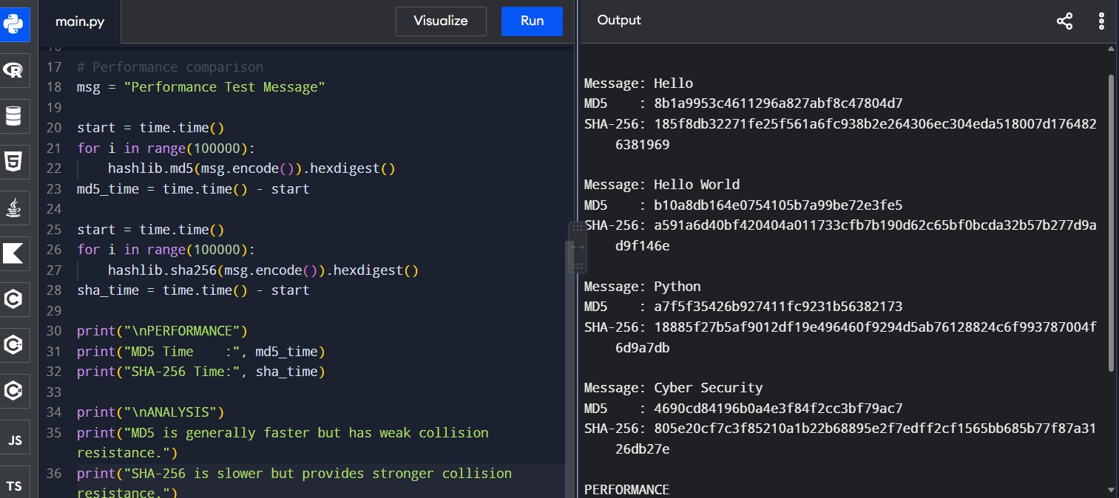

- Develop a Python program to implement a Digital Signature scheme using RSA. Demonstrate message signing and signature verification, and analyze its effectiveness in ensuring integrity and authentication.

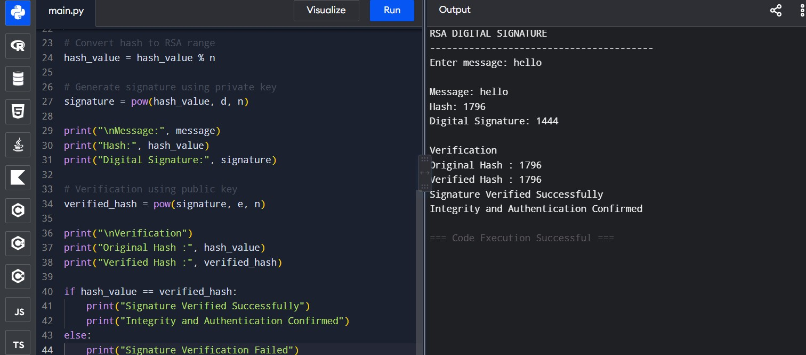
- Write a Python program to simulate HMAC (Hash-based Message Authentication Code) using a chosen hash function. Compare its security properties with a simple hash-based integrity check.

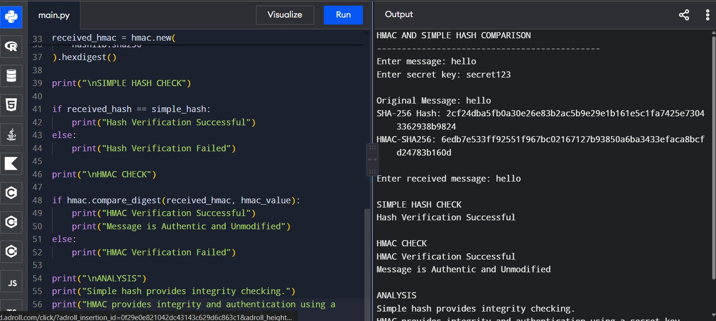
- Implement a simplified Kerberos authentication mechanism in Python to simulate ticket generation, distribution, and validation between a client and server. Analyze its effectiveness in preventing replay attacks.
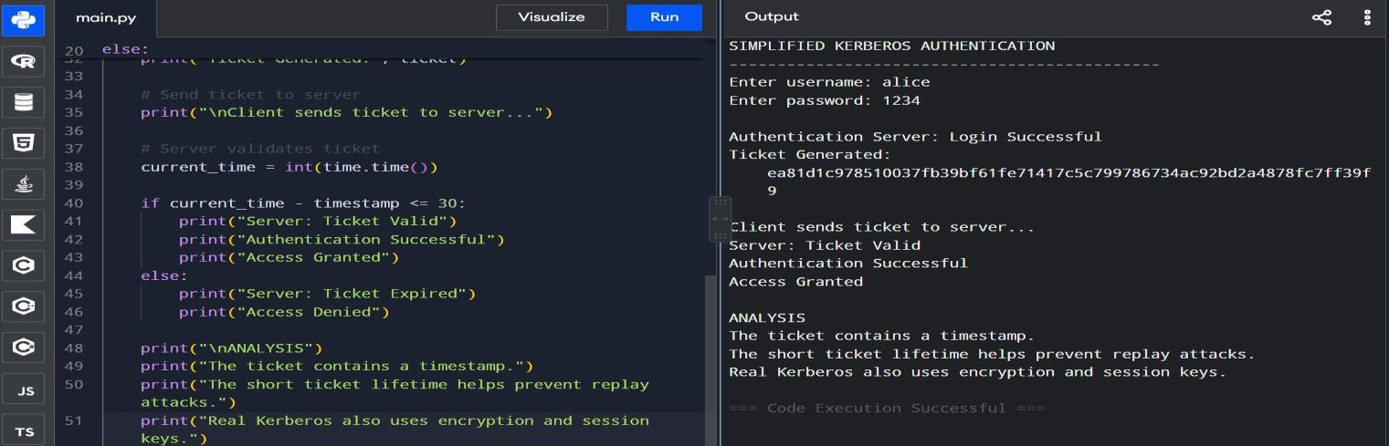
- Develop a Python-based implementation of either the ElGamal or Schnorr digital signature scheme, and evaluate its security features compared to standard digital signature approaches.
